AN ENERGY EFFICIENCY OF CLOUD BASED SERVICES USING EaaS TRANSCODING OF THE MULTIMEDIA DATA.
Abstract— As an alternative to conventional office-based computing, the Network-based cloud computing is rapidly expanding all over. Cloud computing has become widespread and the energy consumption of the network and computing resources. This happens when there is increasing attention being paid to the need to manage energy consumption across the entire information and communications technology (ICT) sector. Also data center energy use have much attention, as there has been less attention paid to the energy consumption of the transmission and switching networks. This paper describes an analysis of energy consumption in cloud computing. The analysis will consider both public and private clouds. This we can show by using energy consumption in transport and switching can be a significant percentage of total energy consumption in cloud computing. Cloud computing provides more energy efficiency and use of computing power. Computing tasks are of low intensity or infrequent. Thus, under some circumstances cloud computing may consume more energy than conventional computing where each user performs all computing on their own personal computer (PC).

The De-duplication method best suited to protect data in cloud. This process De-duplicates data both across backups and within backups and does not require any knowledge of the backup data format. The job can be system allocation can be performed for the batch jobs with the sequence of job allocation. And the content similarity is used for the de-duplications process and filtering the De-duplication content. In the time interval, the job can be finished with the effective resources then allocation can be in the order sequences. The included automates filtering, to help an analyst in cloud with similar content by designating of Data duplication can be easily removed by the content similarity algorithm. The workloads can be categorized as per the order of the job work load can be assigned. The scheduling can be maintained as per the sequence of the job within the time interval the particular job can be executed.

Index Terms- Cloud computing, De-duplication,
QoS, SaaS, Paas, IaaS.

INTRODUCTION
The increasing number of availability of high-speed Internet and corporate IP connections is enabling the delivery of new network-based services. Internet-based mail services have been operating for many years so service offerings have recently expanded to include network-based storage and network-based computing. These new services are offered both to corporate and individual users. The cloud computing service model involves the provision to a service provider, of large pools of high performance computing resources and high-capacity storage devices which are shared among end users. There are many cloud service models, generally end users subscribing to the service have their data hosted by the service and also have computing resources allocated. The service provider’s may also extend to the software applications required by the end user. To be successful, the cloud service model may also requires a high-speed network to provide connection between end user and service provider’s infrastructure. Cloud computing offers an overall financial benefit, in that end users share a large, centrally managed pool of storage and the computing resources, rather than owning and managing their own systems. Often using existing data centers as a basis, cloud service providers invest in the necessary infrastructure and management systems, and in return receive a time-based from end users. Since at any one time, substantial number of the end users are inactive, the benefits of the economies of scale and from statistical multiplexing, and also receives a regular incoming stream from the investment by means of service subscription. The end user sees convenience benefits from data and services available from any location, also from having data backups centrally managed, from the availability of increased capacity when needed and from usage-based charging. Important is the last point for many users in that it averts the need for a large one off investment in hardware, sized to suit maximum demand, and also requires upgrading for every few years. There are various definitions of cloud computing and discussion within the IT industry continues over the possible services that will be offered. We present an overview of energy consumption in cloud computing and compare this to energy consumption in conventional computing. It is the energy consumed when the same task is carried out on a consumer personal computer (PC) that is connected to the Internet but does not use cloud computing method. We consider both public and private clouds that include energy consumption in switching and transmission, data processing and data storage. Specifically, we present a network-based model of user computing equipment, and a model of the processing and storage functions in data centers. We examine a variety of cloud computing service scenarios in terms of energy efficiency. Our approach is to view cloud computing as an analog of a classical supply chain logistics problem, which considers the energy consumption or cost of processing, storing, and transporting physical items. The difference in our case is the items are bits of data. We explore a number of practical examples in which users customers outsource their computing and storage needs to a public cloud or private cloud. The three cloud computing services are considered, including storage as a service, processing as a service and software as a service. As the name implies, storage as a service allows users to store data in the cloud. Processing as a service gives users the ability to outsource selected computationally intensive tasks to the cloud. Software as a service combines these two services and allows users to outsource all their computing to the cloud and use only a very-low-processing-power terminal at home. We showed that energy consumption in transport and switching can be a significant percentage of total energy consumption. Cloud computing can enable more energy-efficient use of computing power. However, we show that under some circumstances cloud computing can consume more energy than conventional computing on a local PC. Our conclusion is that cloud computing can offer significant energy saving techniques such as virtualization and consolidation of servers and advanced cooling systems.
- Types of service models :
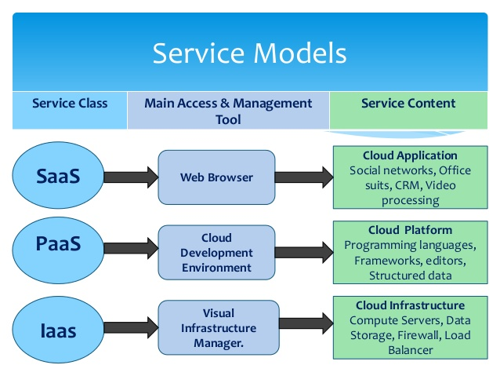

- Storage as a Service

SaaS is a software delivery method that provides access to software and its functions remotely as a Web-based service. Software as a Service allows organizations to access business functionality at a cost typically less than paying for licensed applications since SaaS pricing is based on a monthly fee. Also, because the software is hosted remotely, users don't need to invest in additional hardware. Software as a Service removes the need for organizations to handle the installation, set-up and often daily upkeep and maintenance. Software as a Service may also be referred to as simply hosted applications. With SaaS, cloud providers host and manage the software application and underlying infrastructure and handle any maintenance, like software upgrades and security patching. Users connect to the application over the Internet, usually with a web browser on their phone, tablet or PC.

B) Platform as a Service

PaaS is a category of cloud computing that provides a platform and environment to allow developers to build applications and services over the internet. PaaS services are hosted in the cloud and accessed by users simply via their web browser. Platform as a Service allows users to create software applications using tools supplied by the provider. PaaS services can consist of preconfigured features that customers can subscribe to; they can choose to include the features that meet their requirements while discarding those that do not. Consequently, packages can vary from offering simple point-and-click frameworks where no client side hosting expertise is required to supplying the infrastructure options for advanced development. The infrastructure and applications are managed for customers and support is available. Services are constantly updated, with existing features upgraded and additional features added. PaaS providers can assist developers from the conception of their original ideas to the creation of applications, and through to testing and deployment. This is all achieved in a managed mechanism. As with most cloud offerings, PaaS services are generally paid for on a subscription basis with clients ultimately paying just for what they use. Clients also benefit from the economies of scale that arise from the sharing of the underlying physical infrastructure between users, and that results in lower costs.

- Infrastructure as a Service

IaaS is one of the three fundamental service models of cloud computing alongside Platform as a Service (PaaS) and Software as a Service (SaaS). As with all cloud computing services it provides access to computing resource in a virtualised environment, “the Cloud”, across a public connection, usually the internet. In the case of IaaS the computing resource provided is specifically that of virtualised hardware, in other words, computing infrastructure. The definition includes such offerings as virtual server space, network connections, bandwidth, IP addresses and load balancers. Physically, the pool of hardware resource is pulled from a multitude of servers and networks usually distributed across numerous data centers, all of which the cloud provider is responsible for maintaining. The client, on the other hand, is given access to the virtualised components in order to build their own IT platforms. In common with the other two forms of cloud hosting, IaaS can be utilised by enterprise customers to create cost effective and easily scalable IT solutions where the complexities and expenses of managing the underlying hardware are outsourced to the cloud provider.

PROPOSED METHODOLOGY
The De-duplication method best suited to protect data in cloud. This process De-duplicates data both across backups and within backups and does not require any knowledge of the backup data format. The job can be system allocation can be performed for the batch jobs with the sequence of job allocation. And the content similarity is used for the de-duplications process and filtering the De-duplication content. In the time interval, the job can be finished with the effective resources then allocation can be in the order sequences. The included automates filtering, to help an analyst in cloud with similar content by designating of Data duplication can be easily removed by the content similarity algorithm. The workloads can be categorized as per the order of the job work load can be assigned. The scheduling can be maintained as per the sequence of the job within the time interval the particular job can be executed.

2.1 User Registration and Cloud Access:

Access users only to have authentication process before registration, Authentication process is always occurred prior to mobility management process included location registrations and service delivery, and it also ensures network resources are accessed by authorized clients and prevents resources from any illegal client or damage. Before the registration of cloud services to ensure whether the client is an authenticated or not to access cloud server. We can ensure the information stored in the cloud is used judiciously by the responsible stakeholders as per the service level agreements.

2.2 Indexing the Cloud Data:

The based on requirements to prepare the dataset in avoid de-duplication content. Indexing is nothing but consists of structured and unstructured format. Unstructured format is an unarranged format. Sparse Indexing is based on the reference format and capturing the repeated words queries. Indexing converts the unarranged format into structured arranged format. This may be avoid the problem of delay during searching. Sparse Indexing are used to quickly locate data without having to search every database based on the queries is accessed.

2.3 Finding & Avoiding Similarity:

Content similarity detection is typically performed by means of De-duplication, which is broadly classified into static and content defined. Static approaches split the input data in to equally sized chunks, which are then compared among each other. In order to identify and eliminate duplicates. While simple and fast, static approaches suffer from misalignment issues (i.e insertions or deletions lead to the impossibility to detect duplicates).Comparison phase quantifies the degree of similarity between indexing pairs belonging to the same data.

2.4 Allocating the Workloads Job Management Based on Content Similarity:

The resource can be allocated based on the dependencies of the each job. Based on the dependencies the resource can be allocated. The Content Similarity is a statistical methods to categorize a De-duplication and blocked the adjustable levels of granularity. We cultrate the data set, so that it contains only one representation of each sequence for quantifying and comparative studies. The included automates filtering, to help an analyst in cloud with similar content by designating of Data duplication can be easily removed by the content similarity algorithm.

2.5 Experimental Analysis and Results:

Implementation is often used in the tech world to describe the interactions of elements in programming languages. In Java, where the word is frequently used, to implement is to recognize and use an element of code or a programming resource that is written into the program. One aspect of implementing an interface that can cause confusion is the requirement that to implement an interface, a class must implement all of the methods of that interface. This can lead to error messages due to insufficient implementation of methods. In general, the syntactical requirements of implementation and other tasks can be a burden for developers, and mastering this is part of becoming an in-depth user.

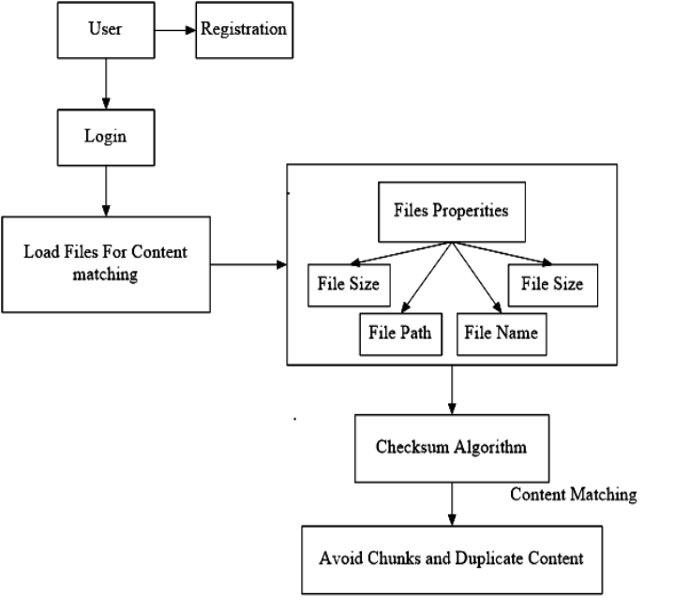

RESULT ANALYSIS AND DISCUSSION
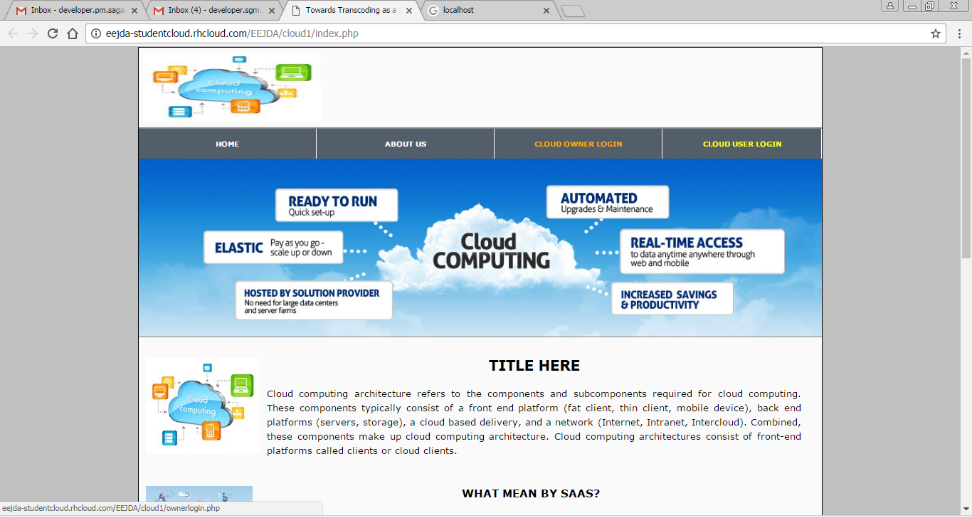

Cloud Owner Side

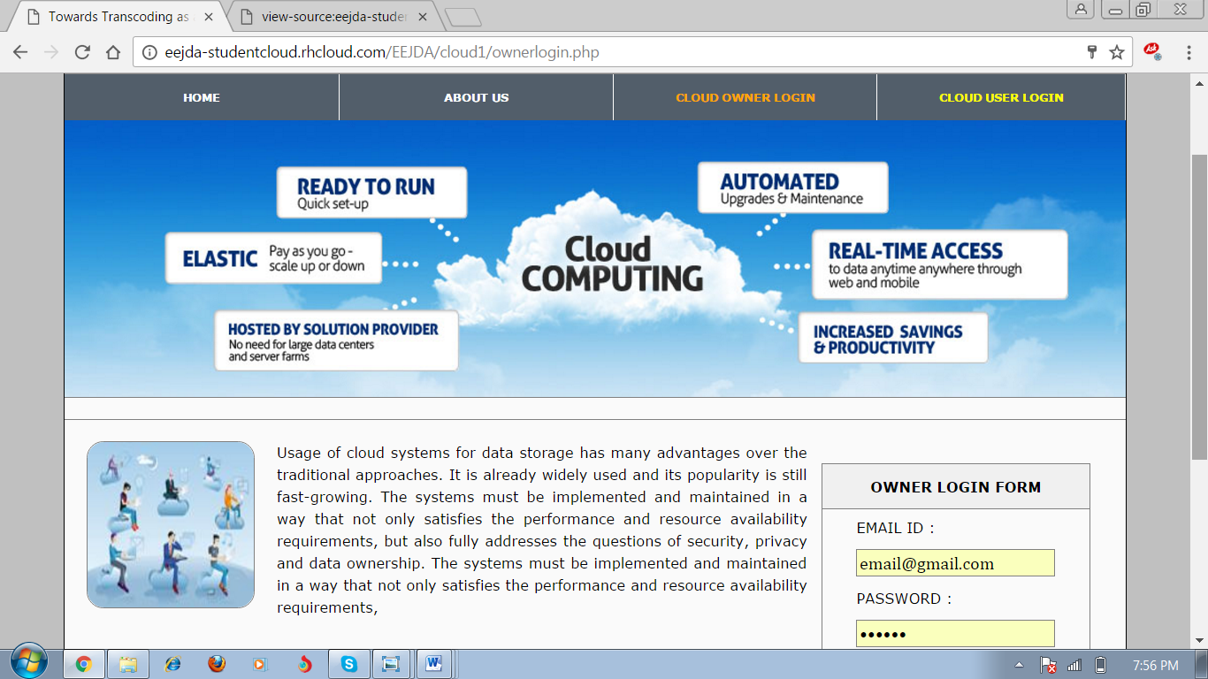

Cloud Owner Login

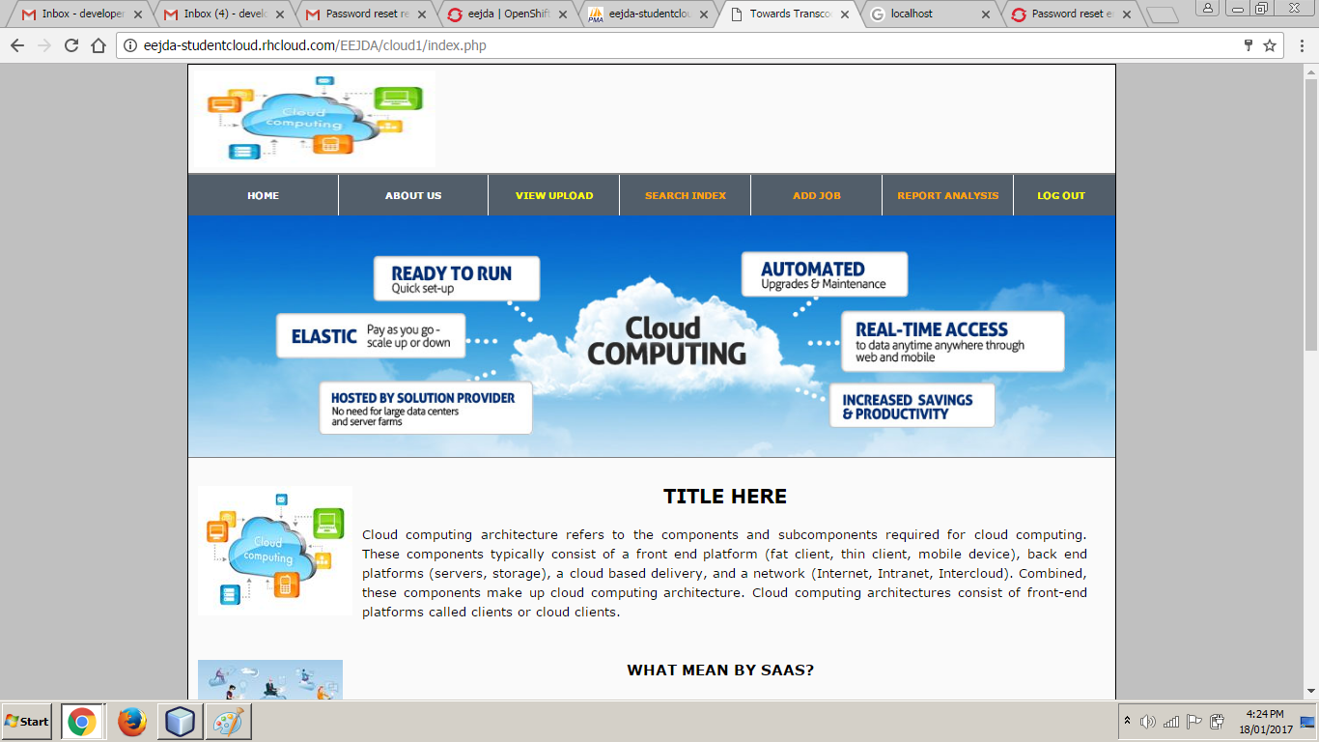

Homepage of Cloud owner

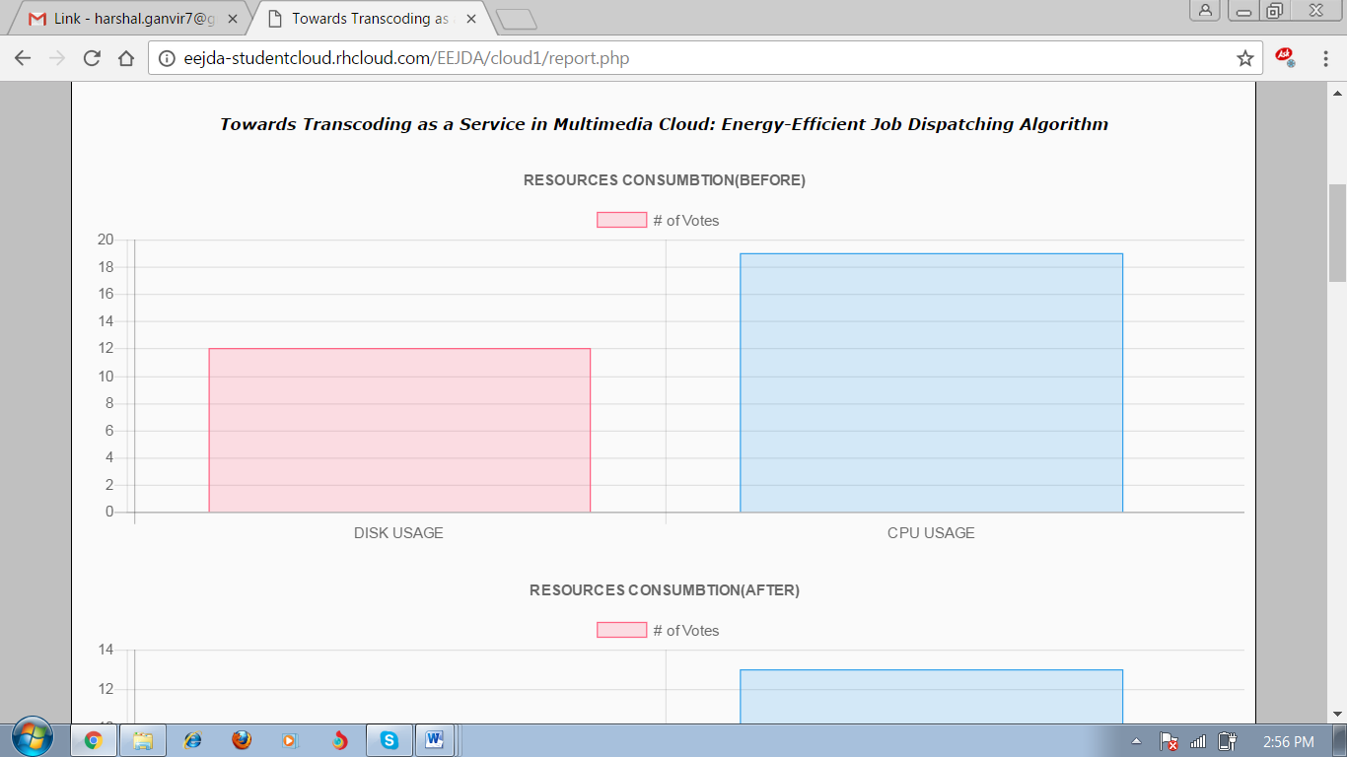
Report 1

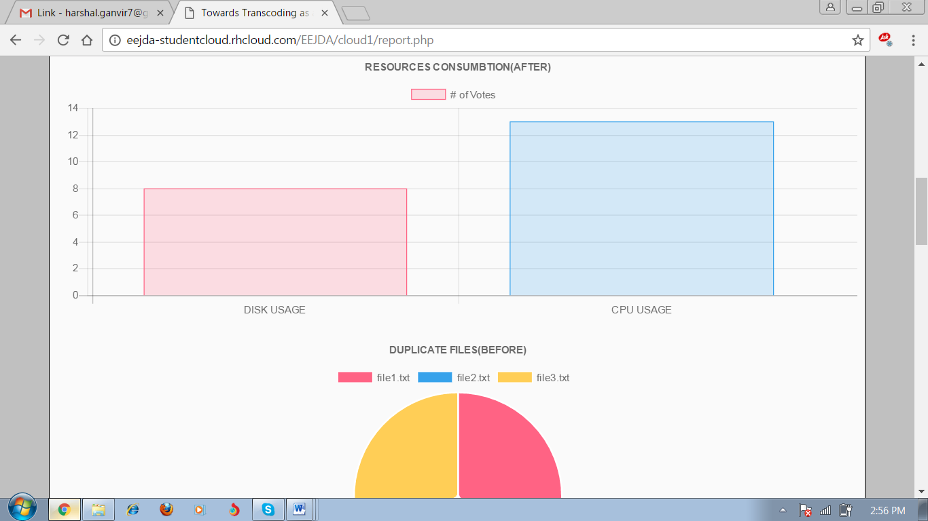
Report 2

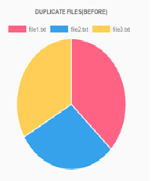
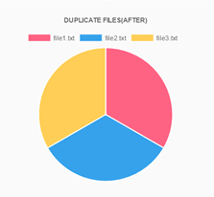
Report 3

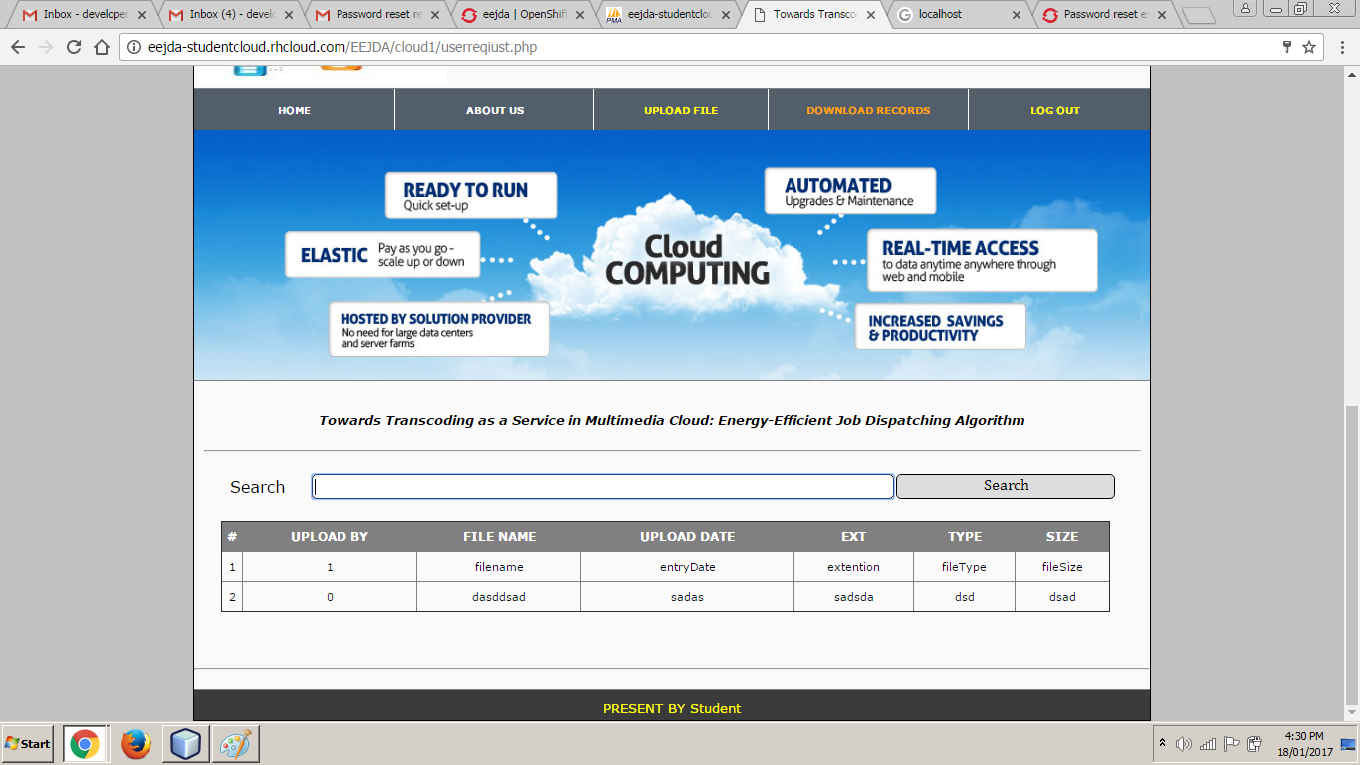

User Homepage

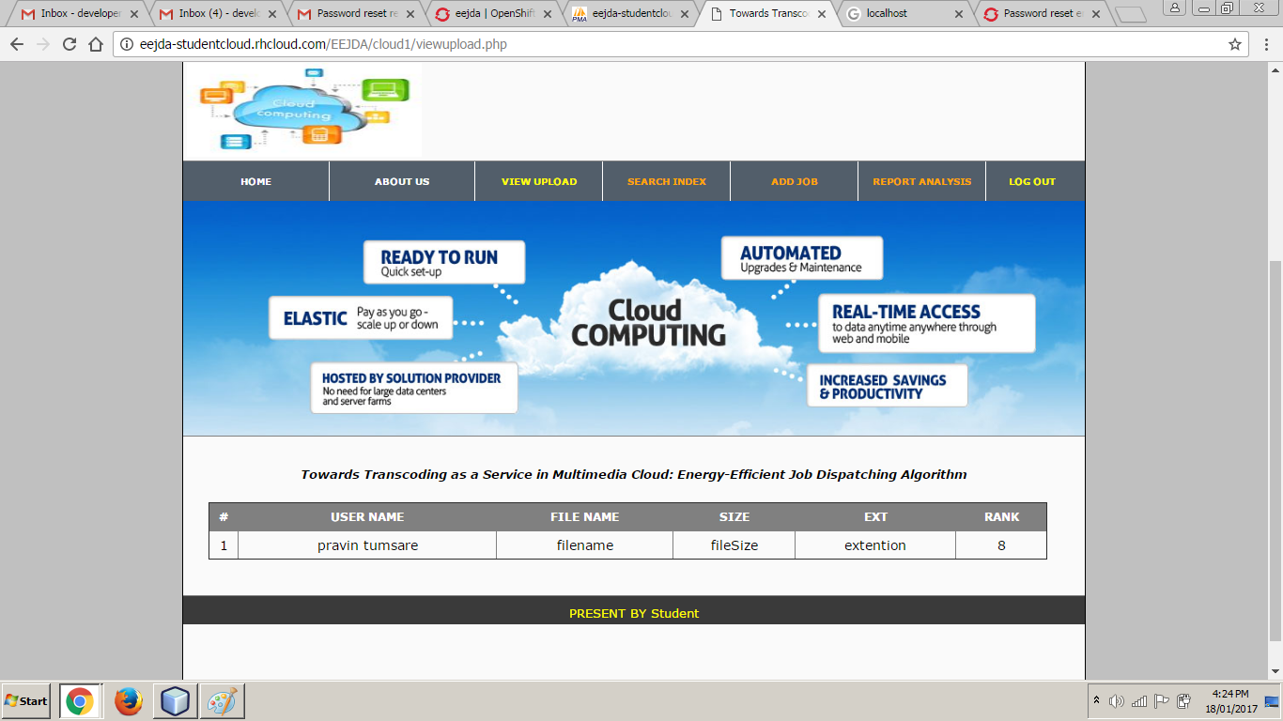

View Upload

CONCLUSION & FUTURE SCOPE
We explored the impact of many factors on the effectiveness of De-duplication. We showed that package installation and language localization have little impact on De-duplication ratio. However, factors such as the base operating system. The Linux distribution can have a major impact on De-duplication effectiveness. Thus, we recommend that hosting centers suggest “preferred” operating system distributions for their users to ensure maximal space savings. If this preference is followed subsequent user activity will have little impact on De-duplication effectiveness. We found that, in general, 40% is approximately the highest De-duplication ratio if no obviously similar VMs are involved. In future work we plan to explore several promising avenues. First, we did not explore what happens when the groups are not operating simultaneously and/or access common content at different times. How to leverage and anticipate such De-synchronizations can provide further potential for improvement. Second, our approach treats all chunks individually, both in terms of advertisements and exchanges. Thus, it would be interesting to understand and exploit correlations between chunks.
Acknowledgment
Success is the manifestation of diligence, perseverance, inspiration, motivation and innovation. A Successful project is fruitful culmination of efforts by many people, some directly involved, and others who have quietly encouraged and extended their supports, while being in the background. There are many persons in Vidarbha Institute Of Technology Nagpur College have supported me from the beginning of my Mtech project. Without them, the project work would obviously not have looked the way it does now. The first person I would like to thank is guide Prof. Pravin G. Kulurkar, H.O.D of Computer Science and Engineering. His enthusiastic engagement in my project work never ending stream of ideas has been absolutely essential for the results, presented here. I am very grateful that he has spent so much time with me discussing different problems ranging from philosophical issues down to minute technical details.

REFERENCES

[1] Cisco Visual Networking Index: Forecast and Methodology, 2012–2017, 2013.

[2] J. Guo and L. N. Bhuyan, “Load balancing in a cluster-based web server for multimedia applications,” IEEE Trans. Parallel Distrib. Syst., vol. 17, no. 11, pp. 1321–1334, Nov. 2006.

[3] D. Seo, J. Kim, and I. Jung, “Load distribution algorithm based on transcoding time estimation for distributed transcoding servers,” in Proc. ICISA, 2010, pp. 1–8.

[4] A. Garcia and H. Kalva, “Cloud transcoding for mobile video content delivery,” in Proc. IEEE ICCE, 2011, pp. 379–380.

[5] Malathi.P “A Survey On Reducing Energy Sprawl in Cloud Computing.” Advanced Computational Intelligence: An International Journal (ACII), Vol.2, No.3, July 2015.

[6] Arindam Banerjee, Prateek Agrawal and N. Ch. S. N. Iyengar ”Energy Efficiency Model For Cloud Computing ” International Journal of Energy, Information and Communications Vol.4, Issue 6 (2013).

[7] Anton Beloglazov and Rajkumar Buyya (2010) “Energy Efficient Allocation of Virtual Machines in Cloud Data Centers “2010 10th IEEE/ACM International Conference on Cluster, Cloud and Grid Computing.

[8] Yogesh Sharma, Bahman Javadi, Weisheng Si (2015) “On the Reliability and Energy Efficiency in Cloud Computing” Proceedings of the 13th Australasian Symposium on Parallel and Distributed Computing (AusPDC 2015), Sydney, Australia, 27 - 30 January 2015.

 

